Wearable Futures Fieldwork Documentation

Inspirations

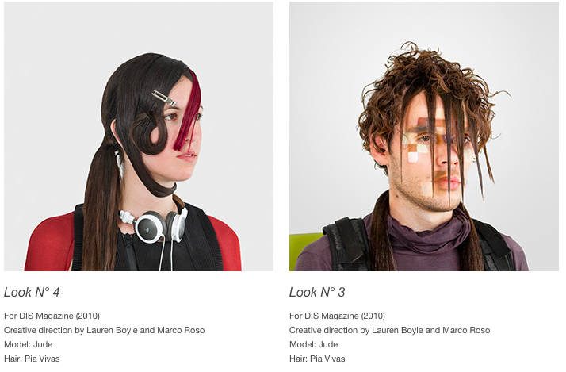
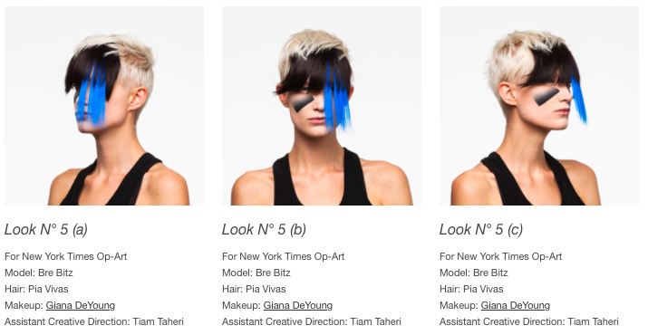
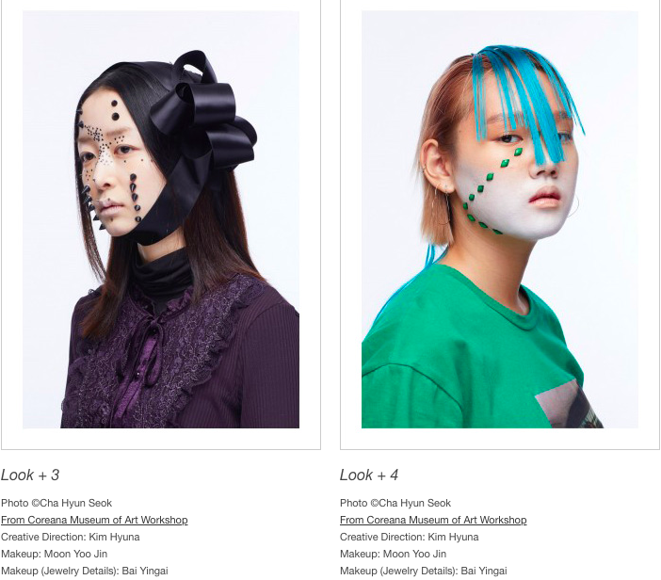
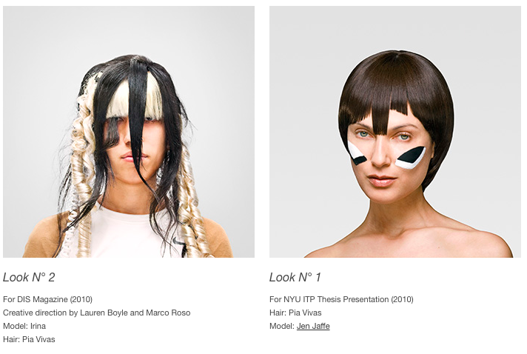

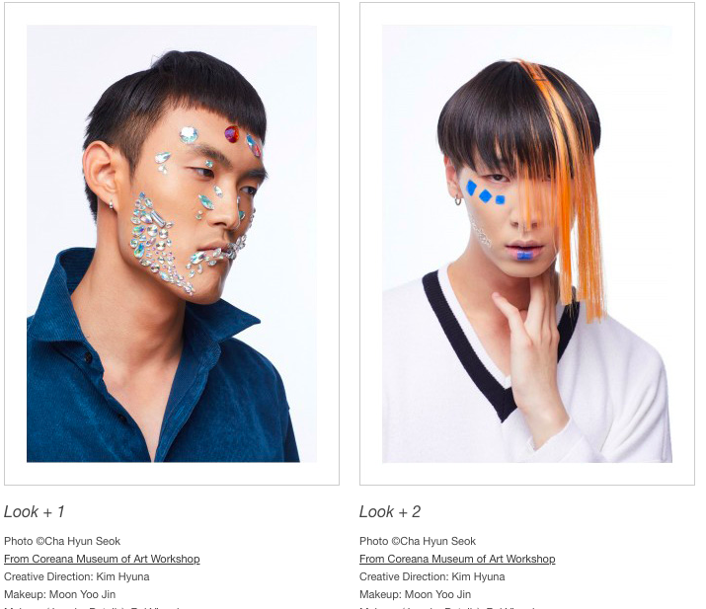

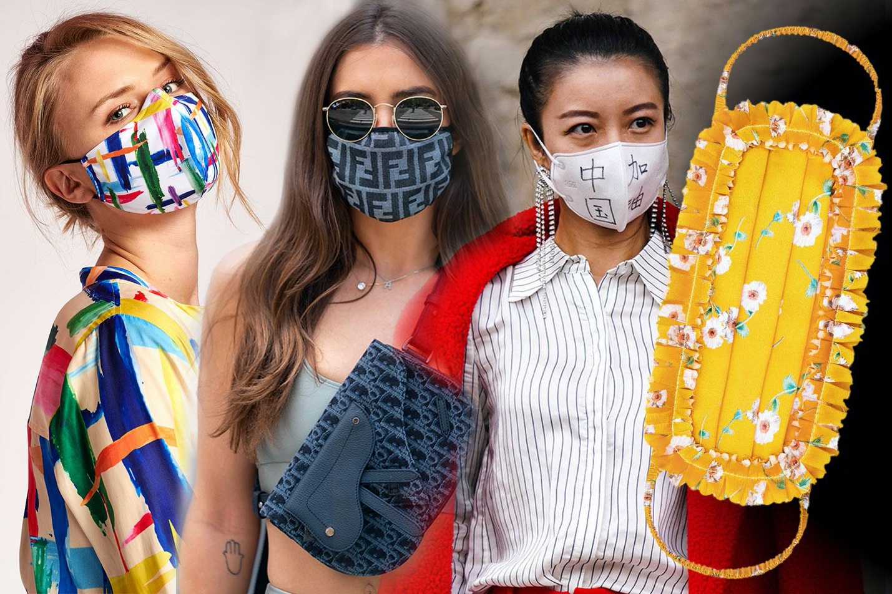
The future of face covering:
Face covering played with within the concept of art with the ‘balaclava trend’ which designers such as Calvin Klein and Alexander Wang were involved in. Also, the concept of having a (legally) unrecognizable face, in relation to the Viola-Jones face detection algorithm.

Social implications of face covering – the ‘burqa ban’ in countries such as France for the purpose of ‘safety’ and ‘identification’. Now, with the Covid-19 pandemic, almost all countries in Europe have made face masks a legal requirement.

Begs the question of whether social attitudes will adapt after the pandemic to understand the want for face covering; and whether face covering/concealment will be able to become a form of self-expression, even in our society which relies on social media and facial recognition through smartphones. With our views on anonymity and concealment being blurred, would be interesting to contemplate the future of masks, balaclavas, veils and other face coverings.


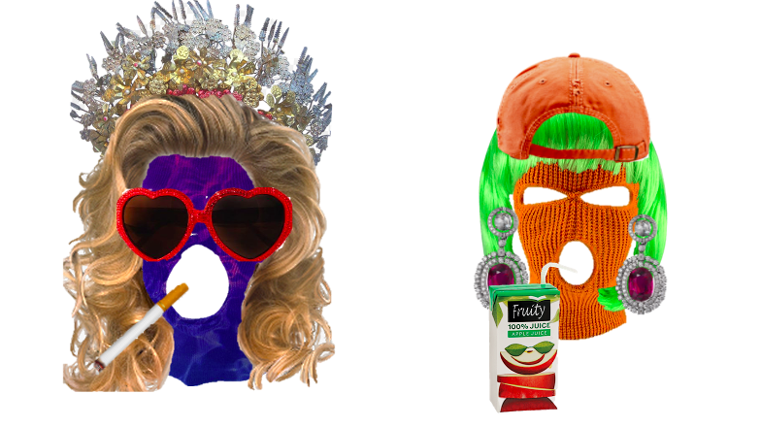
Exploration

